**Institute of Technology Tralee**

**Computing Department**

**Object Oriented Programming 1**

**__________________________________________________**

**Tutorial 10 – Basic Java GUIs**

**Q1**

Write a Java program that mimics the game of Higher/Lower. It should contain a JFrame window. This window should contain 2 labels, a text-field and a button. It should have dimensions of 350 x 100 pixels. It should use a flow-layout style and the application should terminate when the close button is hit on its title bar. The first label should simply prompt the user to guess a whole number between 1 and 100. This value should be input by the user into the text-field. A random number between 1 and 100 will be generated **outside of any method** to begin with. When the user presses the “Compare” button, then the value entered by the user should be compared with the random number and then wiped from the text-field for the next input value. If the number entered by the user is greater than the random number then the message “Go Lower!” should appear on the second label, also indicating how many guesses the user has remaining. If the number entered by the user is smaller than the random number then the message “Go Higher!” should appear on the second label. If they match then the message “Congratulations!” should appear on the second label. The user should get a maximum of 5 attempts to guess the correct number. If they are still wrong after the 5th attempt then the label should display the message “Sorry – you have lost this time – the correct number was X”, where X represents the randomly generated number.

You can assume here that the user enters only valid integer values for their guess so you **don’t need to concern yourself with validation** of any description.

You should make use of the **appendix** of method definitions from the X: drive when answering this question.

Some sample runs of the program are as illustrated below.

**Sample Screenshots**

**After launching the application it appears as follows – the random number has already been generated at this point**

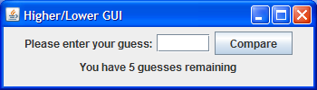

**The user enters their first guess (45 in this case) and presses the button so that it can be compared to the random number. As soon as the button is pressed the value entered is wiped from the text-field. It turns out that the random number is greater than the guess so the message “Go Higher” appears on the label and now the user has 4 guesses remaining:**

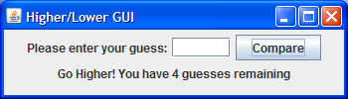

**The user enters their second guess (70 in this case) and presses the button to discover the value entered is now too high. 3 guesses now remain**

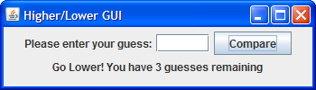

**The user continues to enter further guesses but in this case none of them turn out to be correct. After the 5th incorrect attempt the user gets the “Sorry” message and is also told the correct number.**

